|  |  |
| --- | --- |
| **Name:** | MANSI UNIYAL |
| **Roll Number:** | 19EE10039 |

**Experiment No. 10**

**Name of the Experiment: Study of Differentiator and Integrator using Op amp**

1. **Aim of the experiment**
2. Explain Differentiator using Op amp
3. Explain Integrator using Op amp
4. **Tools used:**

* Stimulation: Vlabs
* Connecting wires
* Resistance
* Capacitor
* Op amp
* Oscilloscope
* Voltage input
  + Square wave
  + Sinusoidal wave

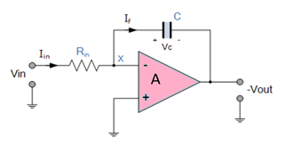

1. **Background knowledge (brief):**

* Integrator
* Output is proportional to the amplitude and time duration of the Input.
* Circuit layout is same as an inverting amplifier but the feedback resistor is replaced by a capacitor which make the circuit frequency dependent.
* WORKING: Initially (voltage is applied) the uncharged capacitor allows maximum current to pass through it and no current flows through the Op-Amp due to the presence of virtual ground, the capacitor starts to charge at the rate of RC time constant and its impedance starts to increase with time and a potential difference is develops across the capacitor resulting in charging current to decrease. This results in the ratio of capacitor's impedance and input resistance increasing causing a linearly increasing ramp output voltage that continues to increase until the capacitor becomes fully charged.
* 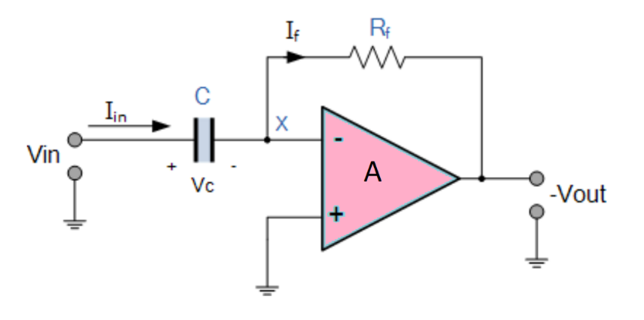Differentiator
* Input is connected to the 108-degree inverting output of the Op-Amp through a capacitor(C) and a negative feedback is provided to the inverting input terminal through a resistor (Rf), which is same as an integrator circuit with feedback capacitor and input resistor being replaced with each other.
* Output is the first derivative of the input signal, 180' out of phase and amplified with a factor Rf*C.
* Capacitor allows only the AC and restrict the DC.
* At low frequency the reactance of capacitor is very high causing a low gain and high frequency vice versa.
* At high frequency the circuit becomes unstable.

1. **Circuit (hand drawn/image)**

**Integrator Circuit**

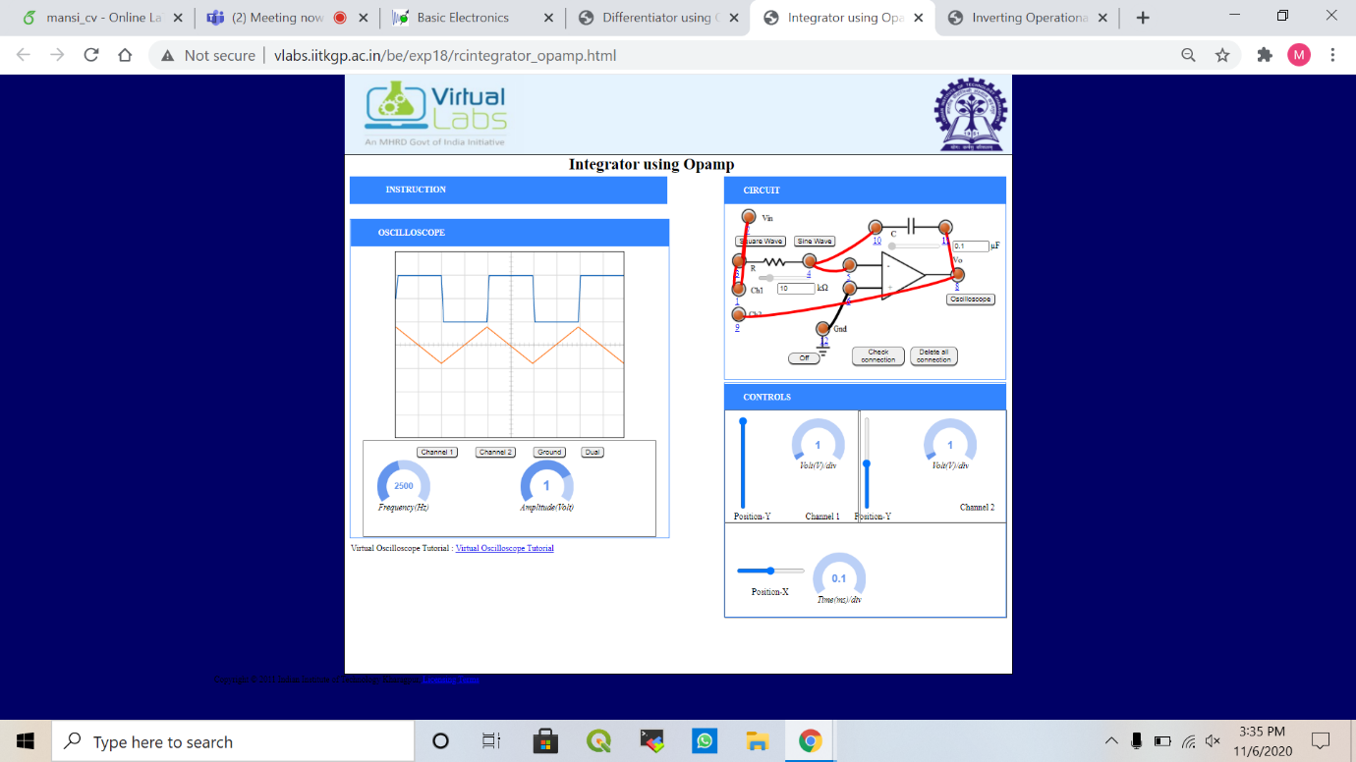

**Differentiator Circuit**

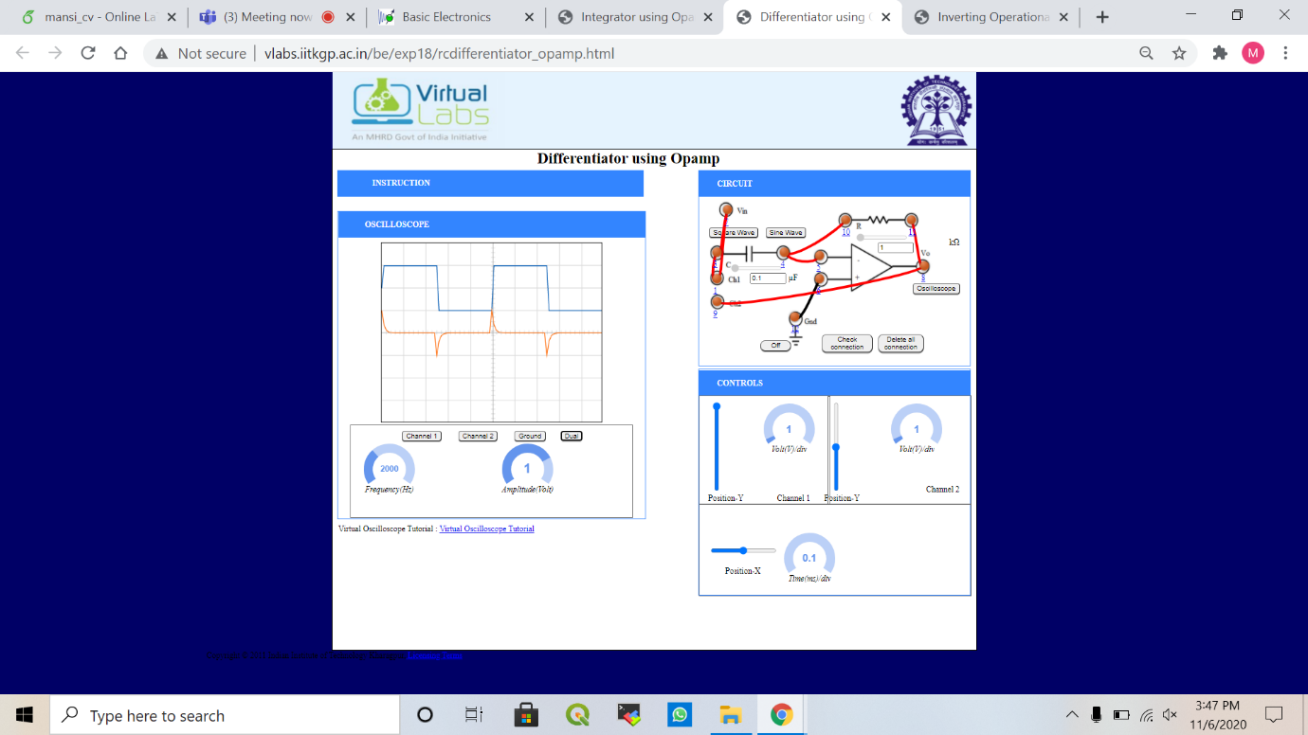

1. **Measurement Data (Tabular form)**

* Frequency is taken as 2000 or 2500 Hz.
* Amplitude is varied from 0.5 to 1.



1. **Graph (Image)/Screenshots**

* Integrator circuit
  + Square wave
    - Amplitude 1



* + - Amplitude 0.5

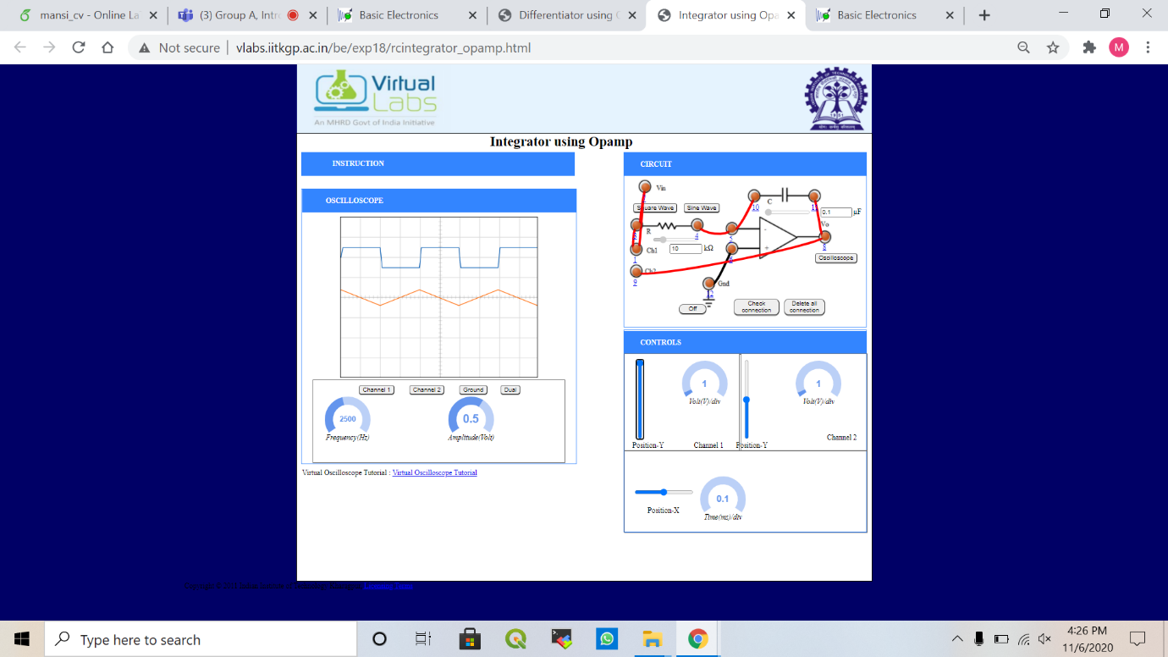

* + Sinusoidal wave
    - Amplitude 1

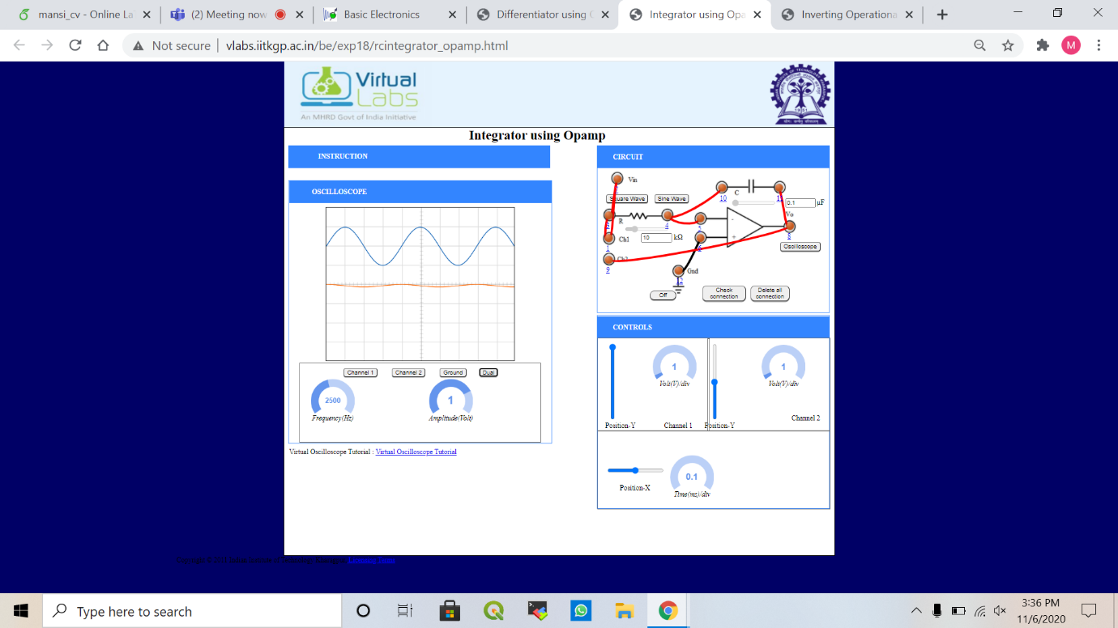

* + - Amplitude 0.5

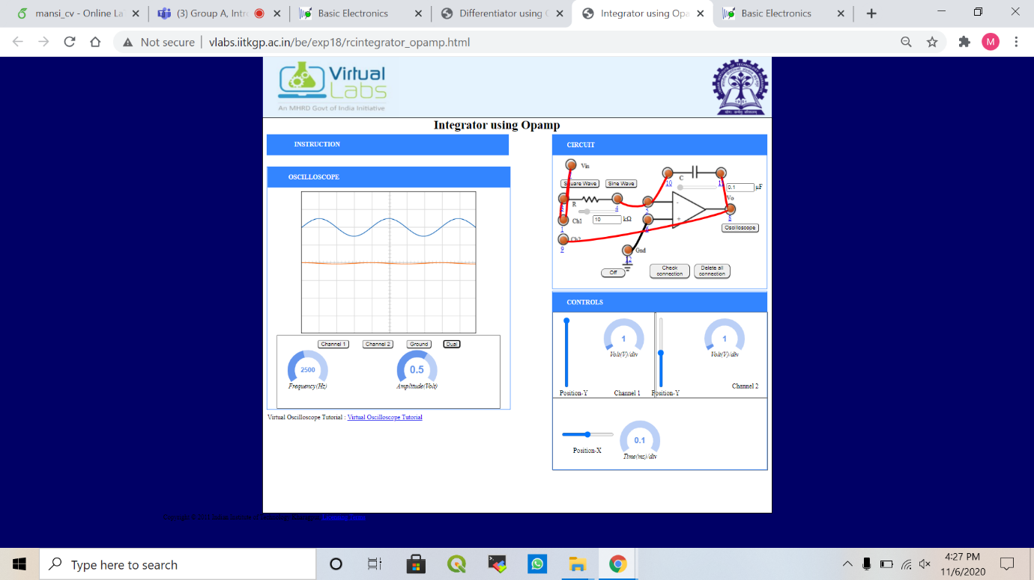

* Differentiator circuit
  + Square wave
    - Amplitude 1



* + - Amplitude 0.5

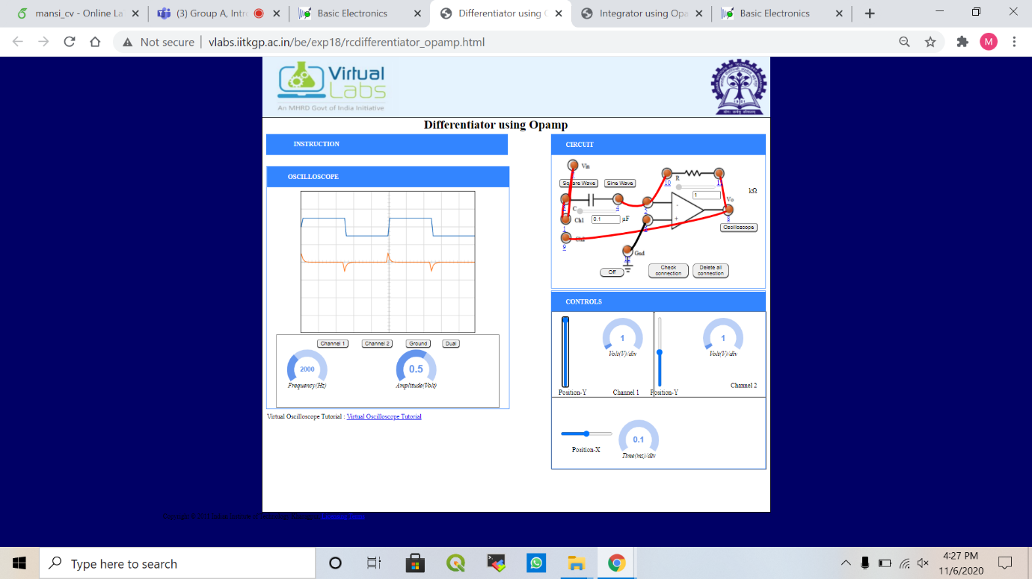

* + Sinusoidal wave
    - Amplitude 1

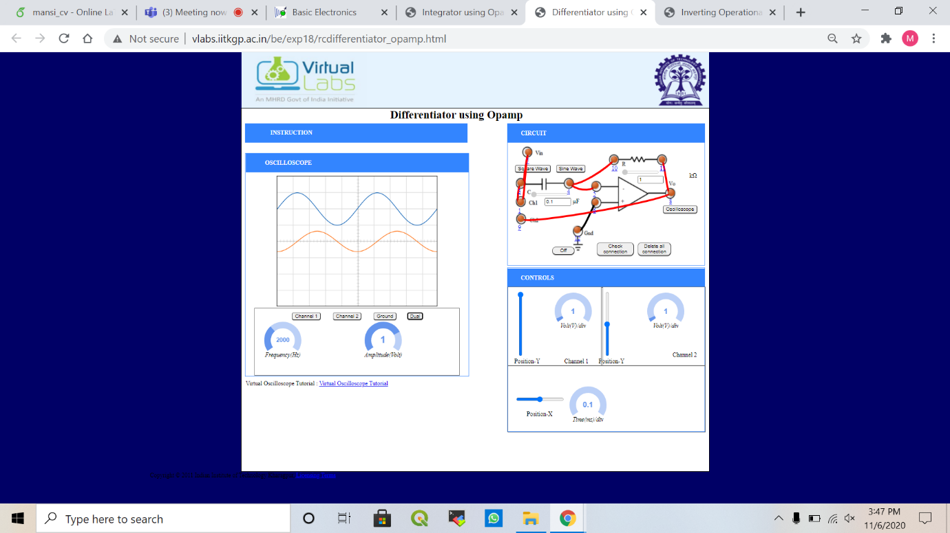

* + - Amplitude 0.5

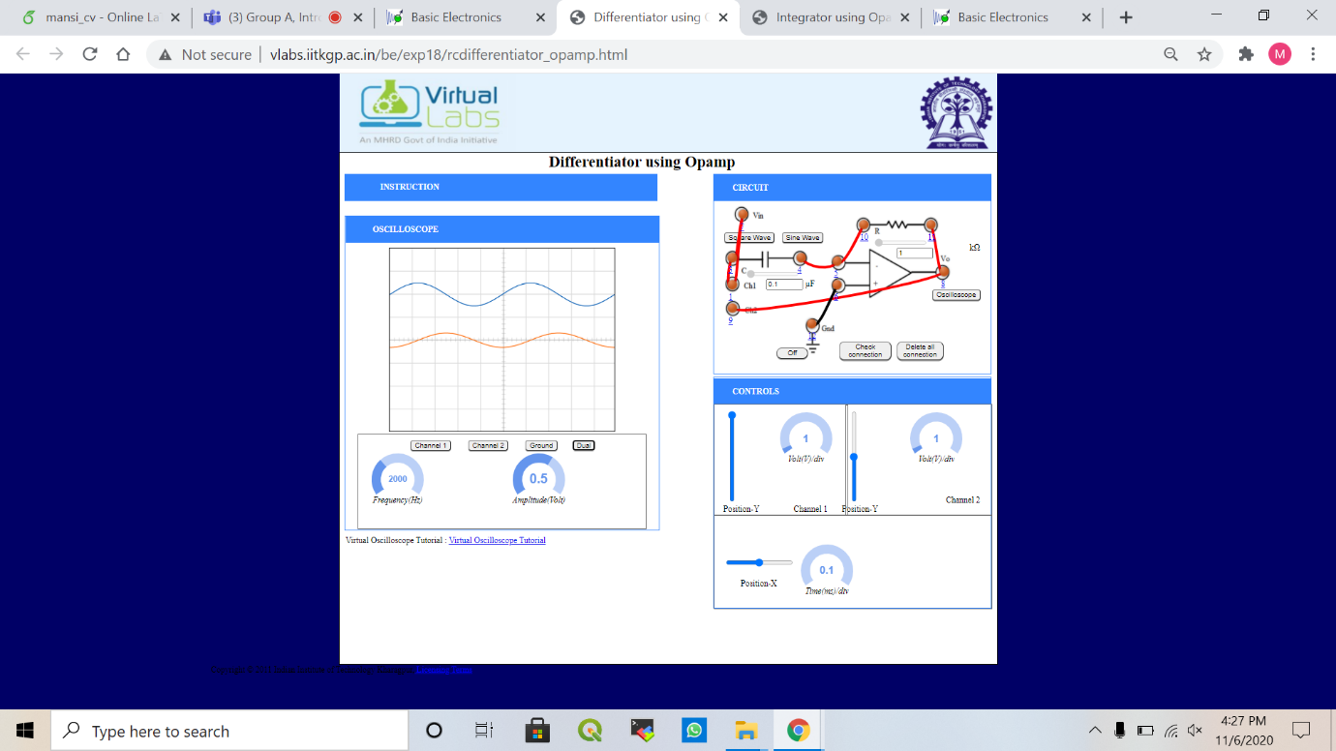

1. **Conclusion**

* Integrator circuit has output where (-) sing indicates 108-degree phase shift.
* Output of differentiator is the first derivative of the input signal, 180' out of phase and amplified with a factor Rf*C.
* Capacitor allows only the AC and restrict the DC.

1. **Discussions**

* Integration of sinusoidal function is sinusoidal
* Integration of square wave is triangle shaped function
* Differentiation of sinusoidal function is sinusoidal
* Differentiation of square wave is impulse function
* Integrator circuit layout is same as an inverting amplifier but the feedback resistor is replaced by a capacitor which make the circuit frequency dependent.